**Drinks**

* Please provide your child with a water bottle to take to school as drinking water throughout the day will keep them hydrated and will help them to concentrate. Children can have a carton of fruit juice or no added sugar squash in their lunch boxes and a water bottle for the classroom.

**Tips for keeping packed lunches fresh**

* Try packing a frozen drink in the lunch box during the Summer; it will help to keep the food cool.
* If you make sandwiches the night before, store them in the fridge overnight.
* Put salad in a separate bag and your child can add it to their sandwich at lunchtime. This will avoid making their sandwiches soggy.

**Snack Time**

* Healthy options such as fruit and fresh vegetables will help your child with their learning and concentration far better than processed foods such as crisps, cakes and biscuits. Many children (and adults) experience a ‘low’ after eating processed and sugary foods. Please ensure when preparing a playtime snack for your child that only fresh fruit or vegetables are provided. Children in Key Stage 2 may bring in money for the snack bar that provides a daily fruit snack for the children.
* Children in Reception and KS1 are provided with a piece of fruit or vegetable each day as part of the School Fruit and Vegetable Scheme (SFVS). This supports your child to eat their 5 A Day!
* It is also preferable that children consume healthy snack options after school when taking part in extra-curricular activities. Please bear this in mind when providing a snack for your child to eat after school.
* **We do not allow nut based products to be consumed in school due to the risk of children with serious allergies being affected.**

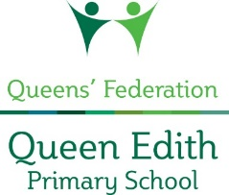

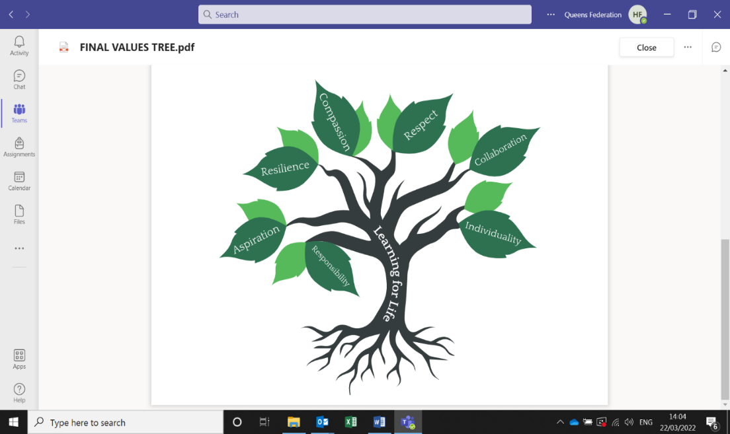

**Happy, Healthy Packed Lunches**

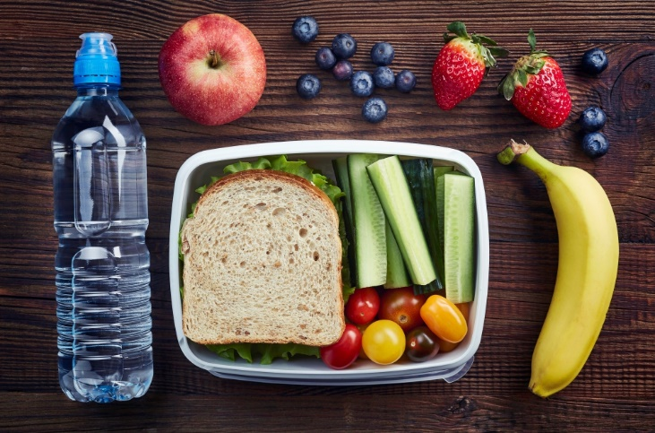

**Top tips for a healthier lunchbox**

Queen Edith Primary School prides itself on being a setting which promotes health and well-being to all its pupils and staff. This leaflet has been created as a guide to help parents / carers provide their children with a varied and balanced packed lunch and includes some practical tips and suggestions.

**What makes a healthy packed lunch?**

* A good portion of starchy (carbohydrate) food e.g. bread, rice, pasta, tortilla wraps, pitta pockets, couscous, potatoes;
* A protein source e.g. lean meat, fish, beans, lentils;
* Plenty of fruit and vegetables;
* A dairy source e.g. low fat yoghurt, semi skimmed milk, cheese;
* A drink e.g. water, no added sugar squash, fruit juice.

These foods provide lots of energy, vitamins and minerals which are needed to help your child grow and stay fit and healthy.

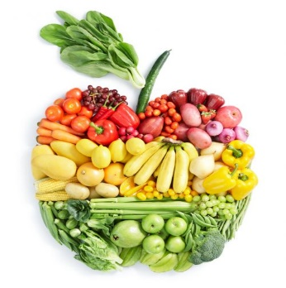**Fruit and vegetables -** Aim to eat at least 5 portions a day

**What is a portion?**

* An apple / banana / pear
* A bowl of salad
* 2 plums / apricots / satsuma
* 3 tablespoons of vegetables
* A handful / small packet of dried fruit
* A handful of grapes / cherries

**Foods to have less often**

* Confectionary foods e.g. chocolate bars, chocolate biscuits, dried fruit, cakes and sweets (sweets are not allowed in school)
* Food that contains a lot of salt e.g. crisps and some other savoury snacks;
* Processed meat such as sausage rolls, burgers and pies.

These are okay to enjoy as an occasional treat but are best avoided as a regular addition to your child’s diet, since they may be high in calories, saturated fat or salt.

**Tasty sandwiches**

* Try to use either brown, wholemeal, granary or multi-grain bread for your child’s sandwich. It is more filling than white bread and will help them concentrate for longer.
* There are many different types of bread that you can introduce your child to. Try to make their lunchbox more interesting by offering them a variety of sandwiches, rolls, tortilla wraps or pitta breads.
* Try to make sandwiches with low-fat fillings, such as lean meats, including ham or turkey, fish (tinned tuna or salmon), cheese, egg or sliced banana.
* Try to add some salad to your child’s sandwich. Lettuce, tomatoes and cucumber can add flavour and colour to your child’s lunchbox.

**Alternatives to sandwiches**

* During the Summer salads are light and refreshing and full of essential vitamins and minerals to benefit your child.
* Pasta salads can also be a good option, such as pasta with tuna and avocado, or pasta with chicken, sweetcorn, cherry tomato and spinach leaves.
* Try to add some vegetables to your child’s lunchbox, such as cherry tomatoes, or sticks of carrot, cucumber, celery or peppers.
* Try to include at least a portion of fruit or vegetables in your child’s lunchbox as this will set them on their way to the recommended 5 portions a day.
* Try to cut down on crisps, which are high in fat, and choose plain pop-corn or breadsticks instead.
* 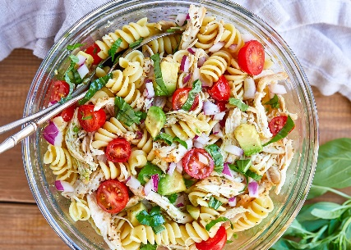As an alternative to fresh fruit, a handful of dried fruit such as raisins, apricots, figs or prunes will help your child on their way to 5 portions a day.
* Instead of cakes, chocolates and biscuits try to include healthier options such as scones, currant buns or fruit bread.
* To ensure that your child gets enough calcium try to include a slice of low-fat cheese, a low fat yoghurt or a low-fat rice pudding.

**Useful websites**

[www.childrensfoodtrust.org.uk/childrens-food-trust/parents/](http://www.childrensfoodtrust.org.uk/childrens-food-trust/parents/)

[www.nhs.uk/Livewell/5ADAY/Pages/5ADAYhome.aspx](http://www.nhs.uk/Livewell/5ADAY/Pages/5ADAYhome.aspx)

[www.nhs.uk/change4life](http://www.nhs.uk/change4life)

[www.nhs.uk/healthier-families/recipes/healthier-lunchboxes/](http://www.nhs.uk/healthier-families/recipes/healthier-lunchboxes/)

[www.bbcgoodfood.com/recipes/collection/lunchbox-recipes](http://www.bbcgoodfood.com/recipes/collection/lunchbox-recipes)