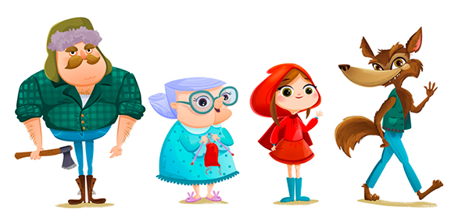
PSHCE: Myself and my relationships: Anti-bullying

D&T:
Designing, making and evaluating a freestanding structure: a strong and stable bridge for the Three Billy Goats to cross the river.

Fairy Tales
Year 2 are finding out about traditional tales this half-term. We will be thinking about and describing characters and settings in detail. We will explore the narrative themes and see how tricky problems can be solved to create happy endings. We will also be writing and adapting our own tales. If you have any expertise on areas of the topic we are covering this half-term and would like to share please let us know.

We will need lots of reclaimed materials for our DT projects – small cardboard boxes (cereal box sized or preferably smaller, eg. toothpaste tube boxes), cardboard tubes, etc. Instead of putting these (clean!) items in your recycling bin, please send them into school!

PE:
Gymnastics

Sending and Receiving

Computing:
Coding. Understanding algorithms, writing and debugging code using Purple Mash.

Geography:
Exploring the characteristics of the UK and honing our locational knowledge. This will include the capital cities, seas and countries of the UK. We will also create our own fairy tale maps.

Science:
Materials and their properties.
Identify and compare the suitability of a variety of everyday materials, including wood, metal, plastic, glass, brick, rock, paper and cardboard for particular uses.

RE:
Christianity – based on the Christmas story. Investigating: Why was Jesus given the name ‘Saviour’?

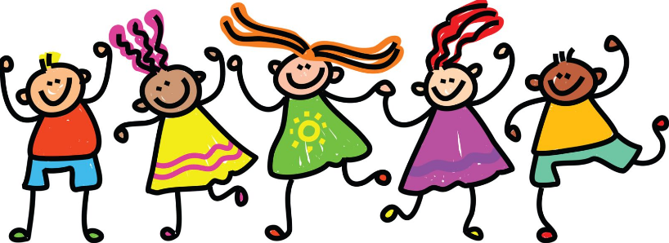
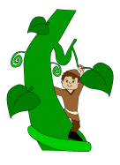
Literacy:
- Capital letters, full stops and using a range of punctuation.
- Sentence openers, exciting adjectives and verbs, and the use of conjunctions.
- Reading for understanding, focusing on retrieval and inference.
- Texts types used for reading and writing: character descriptions, stories and letters.
- Handwriting – correct precursive letter formation and beginning to join.
- Lots of drama and retelling of traditional tales.

At home: Read a variety of text types and remember to ask lots of questions about the book, including characters’ feelings and actions to deepen understanding.

Maths:
- Adding and subtracting
- Solving context based problems related to addition and subtraction.
- 2D and 3D shapes: properties and names
- Lines of symmetry

Music:
Focusing on tempo and dynamics

