Year 5 Summer 1 Optional Homework Topic Mountains and Rivers

Which challenges will you choose to complete?

Find out about the world’s tallest mountains. Which continent and countries are they in? How tall are they? Make a fact file. | Masterchef – create a meal that would provide the essential energy required for a mountain hike. Or why not make a fruit and nut energy bar. | Imagine you are an explorer. Write a diary entry about the day you summited a mountain.
Investigate dams. Explain why they are built the way that they are.  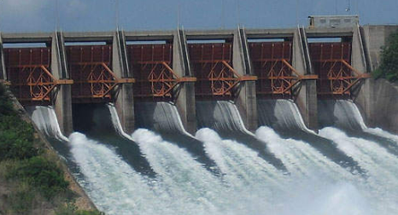 | Build a mountain range using Lego, modelling clay, cardboard, papiermache. You could even make a mountain cake! | Create a boat out of paper that would be able to float in water. Does it work?  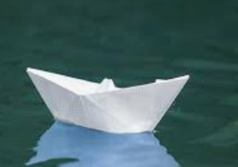
Survival bag – Decide what you would include in your survival bag for a trek up the Himalayan Mountain Range. You may take 10 items for you to carry personally. What will you need? | There are many dangers that you must be prepared for when climbing. Find out about one of the medical problems climbers may encounter and how to avoid or cure them: Hypothermia; Altitude Sickness; Dehydration; and Frostbite. | Compare and contrast some World or UK Rivers and present them in an information booklet.

