Science:

Animals, including humans

Art:
Designing a motif inspired by Egyptian patterns and symbols
Using relief printing to create a print
Experiment with various surfaces

RE:
Humanism

English:

Egyptian themed:
- Newspaper report
- Narrative

Writing focus:
- Verb conjugation in past, present, future
- Word classes
- Fronted adverbials
- Figurative language

Reading:
The London Eye Mystery by Siobhan Down
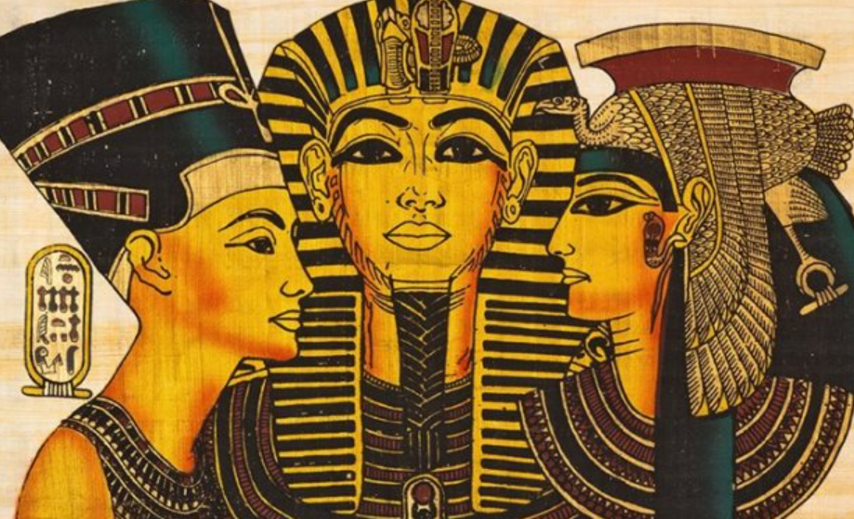
ANCIENT EGYPTIANS
This half term, we will be learning about the fascinating history of Ancient Egypt. We will find out when the first pyramids were built and why the River Nile was so important for this great civilization. We will turn into special reporters when we create newspaper articles about the discovery of Tutankhamun’s tomb. We are very excited about our new Art project, which will involve the use of our own block printing to create Egyptian patterns on textiles.

French:
Quel temps fait-il?
What is the weather?

PE:
Gymnastics
Basketball

PSHE:
Managing Safety and Risk

Maths:
- Perimeter
- Area
- Decimals
- Percentages
Computing:
Purple Mash: Word Processing

Music:
Feelings through Music

