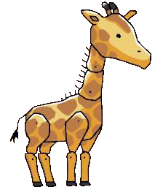
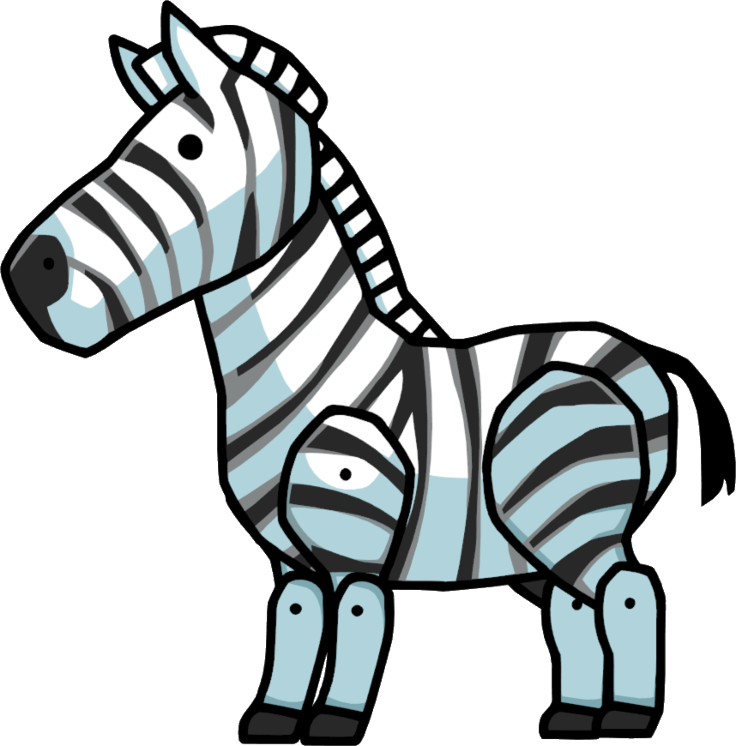
Geography:
Using maps, atlases, globes and digital / computer mapping to locate countries and describe features.
Investigating the human and physical geographical characteristics of Kenya. Understanding the pros and cons of tourism.

PSHCE:
Diversity and Communities
Developing a sense of respect and understanding the needs of others.
PE:
Dance:
African dance
Games:
Handball

AMAZING AFRICA
This half term, we will dive into an exciting Geography topic all about Africa, focusing on Kenya – an amazing country with a rich culture and diverse climate. We'll explore the pros and cons of tourism, eco-tourism, and sustainability, learning how people and wildlife can benefit from responsible travel. Our visit to Shepreth Wildlife Park will inspire our writing and link perfectly to our Science topic on living things and their habitats, as we discover how animals are cared for and protected in different environments.
Computing:
Purple Mash – Spreadsheets
Children will use 2Calculate to create a formula in a spreadsheet to convert measurements of length and distance.

D&T:
Structures: Frame Structures
Design, Make and Evaluate a Zoo Enclosure.

RE:
Judaism- What influences Jewish people?
Children will explore key beliefs and origins of Judaism.


French:
Chez Moi
My Home

English:
- Balanced Argument-‘Should we feed animals in National Parks?’
- Narrative- Based on the book Zoo by Anthony Browne
- Longer text focus: Journey to Jo’Burg by Beverley Naidoo.
Spelling: Learning new spelling patterns and recapping phonics patterns and common tricky words.
Writing: Adverbial phrases; relative and embedded clauses; commas to separate clauses and adverbial phrases; active and passive voice; varied openers including prepositions.
Reading: Whole Class Guided Reading focusing on: Vocabulary, Inference, Prediction, Explanation and Retrieval.

Maths:
- Multiplication using mental and written methods
- Division using mental and written methods
- Fractions
  - Multiplying unit fractions
  - Multiplying non-unit fractions
  - Multiply mixed number fractions
  - Fractions of a quantity
- Finding the perimeter of rectangles and polygons.

Music:
Djembe drumming

Science:
Living Things and their habitats
Describing the differences between the lifecycles of different animals. Describing life processes of reproduction in some plants and animals.

